Nightmare Technical Details

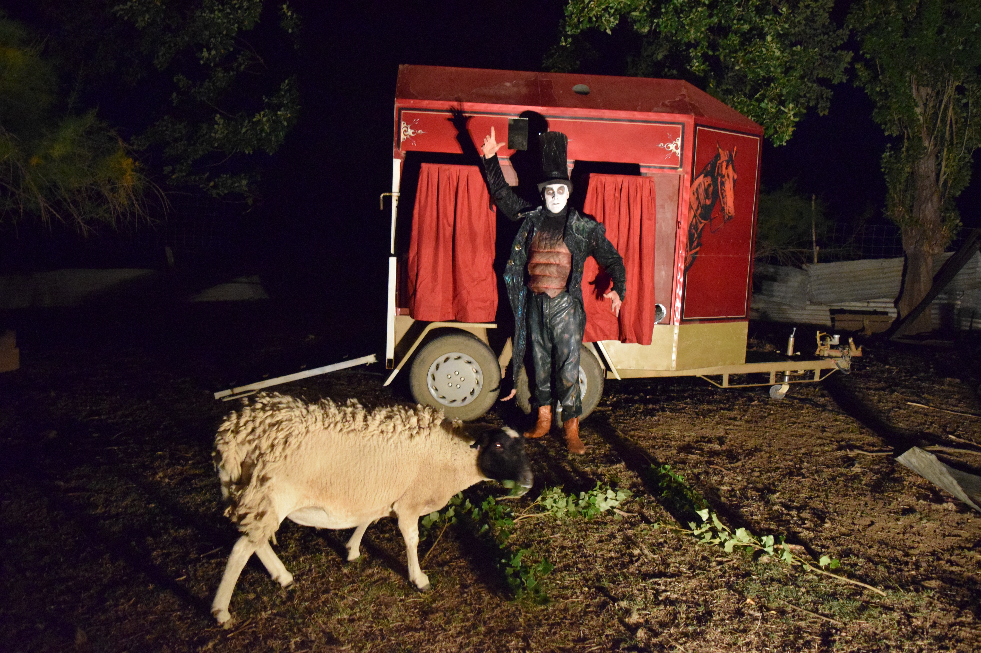

Nightmare Tech Specs

Nightmare is performed inside a horsefloat.

We require 240volt power but Nightmare is otherwise self-sufficient.

Nightmare is performed by Eliza-Jane Gilchrist and Mark Penzak. We both have public liability insurance and current WWC checks.

Horsefloat Dimensions

The Horsefloat is a normal sized double horsefloat. The dimensions are 200cm wide. 525cm in length (that's with the tail gate lowered - 400cm with tail gate raised.)

It's 257cm in height during transport and 377cm high once we placed a rain cover over the top. We also require a minimum 150cm buffer zone around the float.

Location & Installation:

Basically we drive to the location and set up where indicated.

The site has to be fairly level.

Minimal space of 500cm wide by 765cm length x 380cm high.

The horse float can be difficult to maneuver in tight spaces so it is better to give us a spot where we can easily drive in and out. Alternately we can drive close to the performance area and push it into place provided the venue provides 3 or 4 people to help. (Note: If it is pushed in, depending on the situation, the venue may also need to provide help pushing it out.)

On soft or wet grass, a tight turn can rip the surface. It doesn’t seem to hurt the grass though when the horsefloat is driven in a straight line or it’s pushed by hand.

We mount a decorative roof over the horsefloat to protect it from the rain and the heat of the sun but where possible, especially in summer, please place us in the shade as it keeps the horsefloat cool.

Sessions & Show Times: Nightmare's usual arrangement is to do two sessions per day each of 2 hours length. We need a break between the sessions of ideally an hour but we can do less if really needed. (We have run with different arrangements so get in touch if you have a different idea.)

Each performance is 9 min long. Allowing 3 min to reset, we do a new performance every 12 min. That means every two hour sessions will have 10 performances. (20 performances over the day.)

Audience Numbers: Each performance holds 8 people. If we did 20 performances a day that means 160 people. The number of people intrigued by the spectacle is limitless.

Children: Nightmare wasn't designed for kids. The material isn't inappropriate or gory or anything like that but it is strange and performed in a dark space. We recommend it for kids 7 plus but hundreds of younger kids have seen it. Our sign outside recommends it for kids 7 plus and I tell any younger kids who want to enter that the door pushes open so they can leave whenever they like.

Rain: Nightmare is shower resistant but not rain proof. If there's heavy rain, we need to stop.

Hazards: Equipment is tested and tagged. We use a strobe on the inside of the float and indicate that on a notice outside. There’s also a smoke machine on the roof of the horsefloat expelling smoke into the outside air. The smoke machine is optional.

Lights: We provide lights that illuminate the horsefloat, the performer and the audience’s entrance and exit. These do not light much beyond the horsefloat. The event needs to provide lighting for the general area around the horsefloat and for the audience as they walk to and from the horsefloat.

Bump-In and Bump-out: Assuming good access, it’s a 3 hour bump-in from the time the horsefloat is in place. How long it takes to get the horsefloat into it’s parking location depends on the venue. We usually allow 20 minutes. Let us know if its a difficult location and we’ll add more time. It’s a 2 ½ hour bump out again assuming an easy to drive out of location. Let us know if this is a problem as we can do it faster but we'd rather take our time and avoid stress where possible.

Front of House – We've found it's a really good idea for the venue to provide someone to monitor front of house. We can do it alone but it’s difficult for us to stop people jumping the cue while we’re performing.

For any questions please contact

Eliza-Jane Gilchrist

suchastheyare@gmail.com 0437 481 230 www.suchastheyare.com

