- Transplant Reviews from 2015 Melbourne Fringe

THEATRE PRESS
Viewing and re-viewing Melbourne theatre

Such As They Are Presents TRANSPLANT
(http://theatrepress.com.au/2015/10/02/review-such-as-they-are-presents-transplant/)

Posted on October 2, 2015 by scherazade

Gets under your skin and touches your heart
By Myron My

Every now and again, there is a show that is so unexpected and unusual that it remains vividly with you for quite some time after seeing it. Presented by Such As They Are and as part of the 2015 Melbourne Fringe Festival, Transplant is one such show. Performed at its uniquely designed installation space in a corner of Club Voltaire, it is a self-proclaimed “medical fairytale” that seamlessly infuses puppetry and performance.

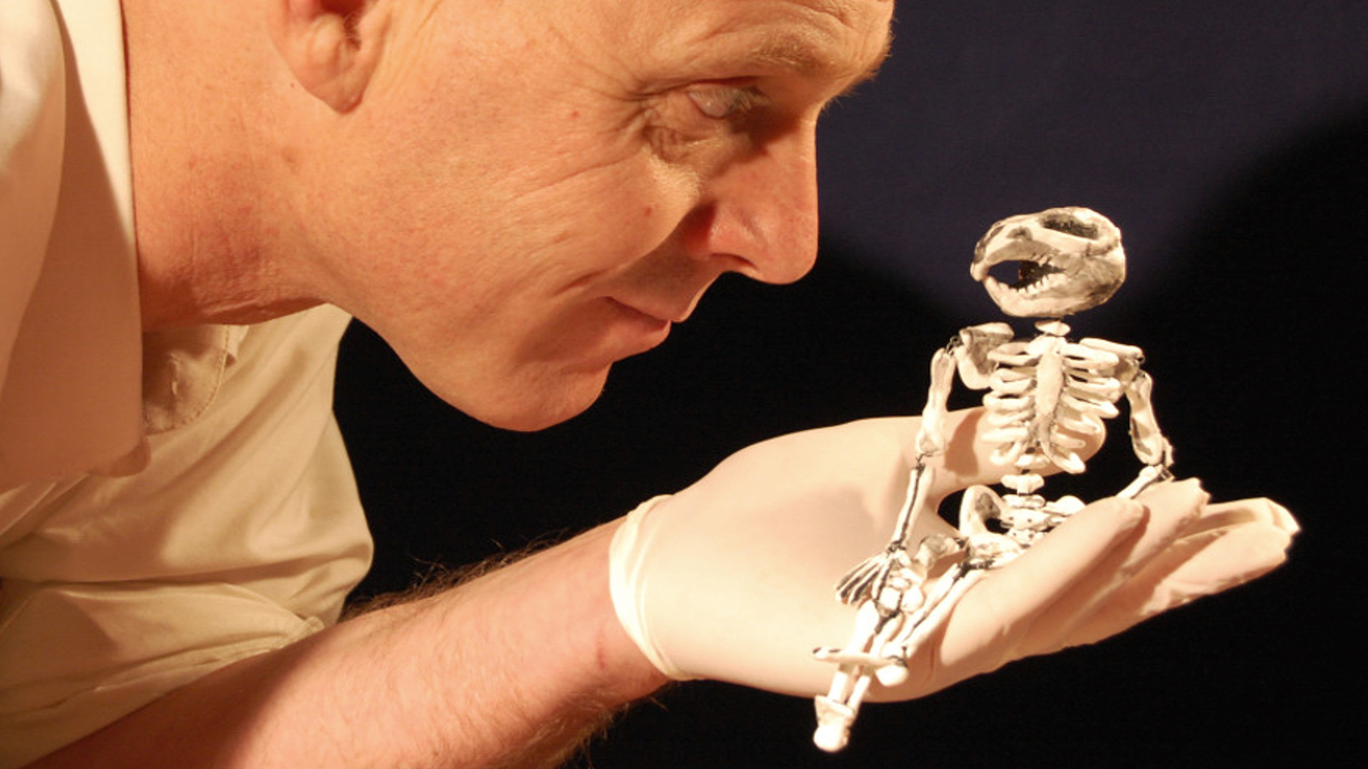

As we wait outside the curtains of the performance, a nurse (Tim Ratcliffe) appears and before we know it, we are being prepped to assist in a surgery. Nothing is forgotten in the process, as we are told to swab behind our ears, have our nostrils examined and if anyone has been travelling overseas in the last month, well…
The whole procedure is quite surreal and preposterous but Ratcliffe does not skip a beat nor give any indication that any of this is an act. Even when the audience is overcome with laughter, he remains beautifully straight-faced and coldly serious. This is the reality we have entered.

Once we are ready, we are led to another room where a surgeon (Mark Penzak) is working hard at keeping his patient – who just happens to be a beautifully constructed puppet – alive. Unlike the first half of the show, the surgery scenes have a strong air of a fairytale world that has been ravaged by a plague. What follows are some highly engaging and visually enchanting moments where the less said about them the better the experience will be.

The two rooms have both been immaculately and authentically designed in Transplant. The lingering smell of disinfectant in the prep room shows that no attention to detail – whether visual or not – has been spared. The same can be said about the puppet design and puppetry by Eliza-Jane Gilchrist, whose creation and mechanics find just the right balance of real and make-believe.

Transplant is a highly entertaining evening that ensures a full sensory experience for its audiences as they explore ideas of life and death and humanity. Due to the nature of the show, it is limited to small number of audience members at a time, so book ahead for this one and enter Such As They Are‘s beguiling fantasy world to see what awaits you.

Limelight's top picks for the Melbourne Fringe

by William Jeffery on September 23, 2015
(http://www.limelightmagazine.com.au/features/limelights-top-picks-melbourne-fringe)

Transplant
Transplant is described as a medical fairytale that combines puppetry, performance and installation in a truly unique experience. After being thoroughly prepped, a small audience are taken to the operating theatre where a body is opened to expose an amazing world contaminated by a mysterious plague. Whilst the show embraces the expectations of theatre it is equally informed by the visuals, symbolic representations and fairytale-like imagery that tap into underlying anxieties and joys.

Transplant was developed through Punctum Seedpod and has appeared in Castlemaine State Festival and the Maldon Puppet Carnaval. It has been described as “Intriguing, surprising and involving” and the company is cited as one that “stretches the limits of animated storytelling”.

My About Town

Top 10 shows of 2015 Melbourne Fringe Festival

http://www.myronmy.me/2015/10/top-10-shows-of-2015-melbourne-fringe.html

This would have to be one of the weirdest shows I saw, a medical fairytale of sorts with puppets and performance and an incredible transformation of the smallest of spaces at Club Voltaire.

Transplant is a genuine full sensory experience of life and death and humanity with some highly engaging and visually enchanting moments. The puppet design and puppetry is also exquisitely executed.

